UCD School of Electrical, Electronic and Communications Engineering

EEEN30110 Signals & Systems

# Lab 1 Report

**Author:** Ruairí O ‘Donoghue **Student Number: 13456968**

### Declaration

I declare that the work described in this report was done by the people named above, and that the description and comments in this report are my own work, except where otherwise acknowledged. I have read and understand the consequences of plagiarism as discussed in the EECE School Policy on Plagiarism, the UCD Plagiarism Policy and the UCD Briefing Document on Academic Integrity and Plagiarism. I also understand the definition of plagiarism.

Signed: . . . . . . . . . . . . . . . . . . . . . . . . . Date: . . . . . . . . . . . . . . . .

**Objective:**

To investigate linear, constant coefficient ODEs and analysis of LTI systems using an example of the dynamics of an aircraft.

**Method:**

Question 1:

The longitudinal dynamics of an aircraft in steady flight are approximately described by the following equations where $α$ is the offset of the angle of attack, $θ$ is the offset of the pitching angle and $δ_{e}$ is the elevator setting.

$$\dot{α}= -0.313α+ \dot{θ}+0.232δ_{e}$$

$$\ddot{θ}= -0.79α- 0.426\dot{θ}+1.16δ_{e}$$

As it is a transfer function I require I will take all initial conditions to be zero. To find the transfer function I first used the Laplace transform to the equations from the time-domain to the s-domain. The equations become:

$$sΑ= -0.313Α+sΘ+0.232Δ_{e}$$

$$s^{2}Θ= -0.79Α-0.426sΘ+1.16Δ_{e}$$

By rearranging these equations in terms of alpha I can equate the two.

$$Α=\frac{sΘ+0.232Δ_{e}}{s-0.313}=\frac{s^{2}+0.426sΘ-1.16Δ_{e}}{-0.79}$$

This allows me to get the equation in terms of Theta over Delta:

$$H\left(s\right)=\frac{Θ}{Δ_{e}}=\frac{1.16s+0.179}{s^{3}+0.739s^{2}+0.9234s}$$

Question 2:

With all initial conditions assumed to be zero the transfer function remains the same as in question 1.

Using the formula:

$$Θ\left(s\right)=X\left(s\right)H(s)$$

X(s) is the input step of 0.1.

$$Θ\left(s\right)=\frac{0.1}{s} \frac{1.16s+0.179}{s^{3}+0.739s+0.9234s}$$

I then used Matlab to get the partial fraction expansion:

$$Θ\left(s\right)=\frac{-0.0551+0.0339j}{s+0.3695-0.8871j}+\frac{-0.551-0.0339j}{s+0.3695+0.8871j}+\frac{0.1101}{s}+\frac{0.0194}{s^{2}}$$

Then using the inverse Laplace transform to get the equation back into the time-domain:

$$θ\left(t\right)=0.0646e^{j2.5902-0.3695t+j0.8871t}+0.646e^{-j2.5902-0.3695t+j0.8871t}+0.1101e^{-t}+0.0194e^{-t}$$

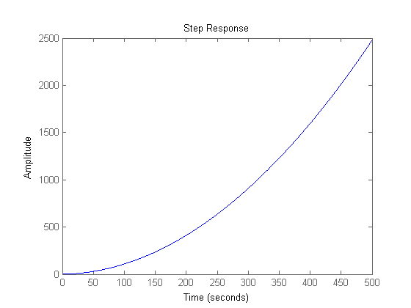Showing $θ(t)$ in real form:

$$θ\left(t\right)=0.2584e^{-0.3695t}\left(\cos\left(0.8871t-2.5902\right)\right)+0.1101+0.0194t$$

Question 3:

We are given the equation below which is a very simple model of an actuator which controls the elevator setting. $τ$ Is a parameter of the actuator model called the time constant and $u_{e}$ is the elevator control signal.

$$τ\dot{δ_{e}}+δ_{e}=u_{e}$$

I will first use the Laplace transform to transform the equation from the time-domain to the s-domain.

$$τΔ_{e}s+Δ_{e}=U_{e}$$

Rearranging the equation I can get the equation in terms of U and Delta.

$$U_{e}=Δ_{e}(τs+1)$$

Now I can get the transfer function of the system.

$$H\left(s\right)=\frac{Δ_{e}}{U_{e}}=\frac{1}{τs+1}=\frac{1}{0.1s+1}$$

Question 4:

To get the transfer function we can use the equations we go in question 1 and 3. By multiplying by the two we can get $\frac{Θ}{U_{e}}$ which is the desired transfer function.

$$H\left(s\right)=\frac{Θ}{U_{e}}=\frac{Θ}{Δ_{e}}\frac{Δ_{e}}{U_{e}}$$

$$\frac{Θ}{Δ_{e}}= \frac{1.16s+0.179}{s^{3}+0.739s+0.9234s}$$

$$\frac{Δ_{e}}{U_{e}}=\frac{1}{0.1s+1}$$

$$H(s)=\frac{1.16s+0.179}{{0.1s}^{4}+1.0739s^{3}+0.8314s^{2}+0.9234s}$$

We can then get the equation for the step function by multiplying it by the initial step of 0.1.

$$Θ\left(s\right)=\frac{1.16s+0.179}{{0.1s}^{4}+1.0739s^{3}+0.8314s^{2}+0.9234s}\frac{0.1}{s}$$

$$Θ\left(s\right)=\frac{0.116s+0.0179}{{0.1s}^{5}+1.0739s^{4}+0.8314s^{3}+0.9234s^{2}}$$

Then using Matlab we can get the partial fractions:

$$Θ\left(s\right)=-\frac{0.0122}{s+9.999}+\frac{-0.5347+0.4009j}{s+0.3695-0.8870j}+\frac{-0.5347-0.4009j}{s+0.3695+0.8870j}+\frac{1.0817}{s}+\frac{0.1938}{s^{2}}$$

Then using the inverse Laplace transform we can shift back into the time-domain.

$$θ\left(t\right)=-0.0122e^{-9.999t}+0.668e^{j2.4983+j0.8870t-0.3695t}+0.668e^{j2.4983-j0.8870t-0.3695t}+1.0817+0.1938t$$

Then converting the equation to the real equivalent:

$$θ\left(t\right)=2.6732e^{-0.3695t}\left(\cos\left(0.8870t-2.4983\right)\right)+1.0817+0.1938t-0.0122e^{9.999t}$$

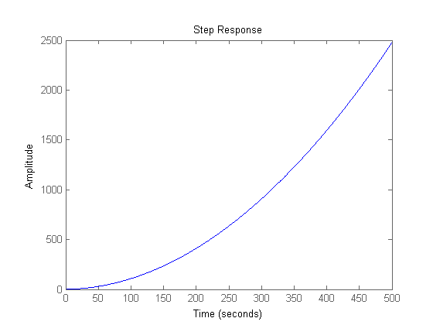

Question 5:

$H\left(s\right)= \frac{1.16s+0.179}{s^{3}+0.739s^{2}+0.9234s}$

-

+

$$θ\left(t\right)$$ Output

r(t)  
Input

$$U_{e}(t)$$

Process

$$δ_{e}$$

Sensor

Controller (Motor)

$$k_{sens}$$

$$H\left(s\right)$$

$\frac{1}{τs+1}$

$$k_{sens}$$

Question 6:

From question 1:

$$\frac{Θ}{Δ_{e}}=H(s)$$

Rearranging this:

$$Θ=H(s)Δ_{e}$$

From question 2:

$$Δ_{e}=\left(\frac{1}{τs+1}\right)\left(U_{e}\right)$$

Combining the two equations we get:

$$Θ=\left(\frac{H(s)}{τs+1}\right)(U_{e})$$

We were given this function in question 5:

$$u_{e}=k_{sens}r-θ_{meas}$$

Using laplace transform to shift from the time-domain to the s-domain:

$$U_{e}=k_{sensR}-θ_{meas}$$

Combining all the equations so far we get:

$$Θ=\left(\frac{H(s)}{τs+1}\right)\left(R-Θ\right)(k_{sens})$$

Rearranging the function so that we get $\frac{Θ}{R}$:

$$\frac{Θ}{R}=\frac{H{(s)k}_{sens}}{τs+1+Hk_{sens}}$$

$a=top of H$ (s) = $1.16s -0.179$

$b=bottom of H(s)$ = $s^{3}+0.739s^{2}-0.6057s$

Subbing in a and b for H(s):

$$\frac{Θ}{R}=\frac{ak_{sens}}{τsb+b+ak_{sens}}$$

Subbing in the values for a and b

$$\frac{Θ}{R}=\frac{0.232s+0.0358}{0.1s^{4}+1.0739s^{3}+0.8313s^{2}+1.1559s+0.0358}$$

Now multiplying by $\frac{0.1}{s}$ to get the step function like in question 2:

$$\frac{Θ}{R}\frac{0.1}{s}=\frac{0.0232s+0.00358}{0.1s^{5}+1.0739s^{4}+0.8313s^{3}+1.1559s^{2}+0.0358s}$$

Using Matlab to get the partial fractions:

$$Θ\left(s\right)= -\frac{0.0002}{s+10.0244}+\frac{-0.0093+0.0056j}{s+0.3415-1.0056j}+\frac{-0.0093-0.0056j}{s+0.3415+1.0056j}+\frac{-0.0812}{s+0.0317}+\frac{0.1}{s}$$

Now using the inverse Laplace transform to shift back from the s-domain to the time-domain.

$$θ\left(t\right)=\left(-0.0002e^{-10.0244t}\right)+0.0108e^{2.5959}\left(e^{-0.3415t}\right)\left(e^{j1.0056t}\right)+0.0108e^{2.5959}\left(e^{-0.3415t}\right)\left(e^{-j1.0056t}\right)-0.0812e^{-0.0317t}+0.1$$

Getting the equation from complex form to purely real form we get:

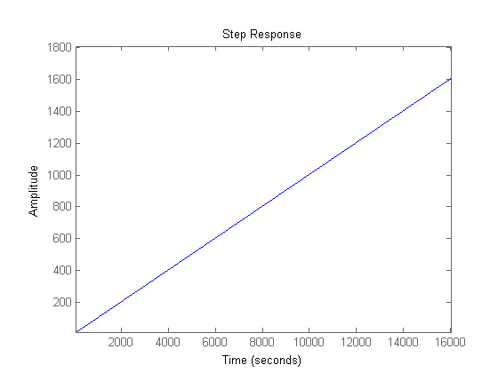 $θ\left(t\right)= 0.0432e^{-0.3415t}\left(\cos\left(1.0056t-2.5959\right)\right)-0.0002e^{10.0244t}-0.0812e^{-0.0317t}+0.1$